安裝 nodejs -> https://nodejs.org/zh-tw/download
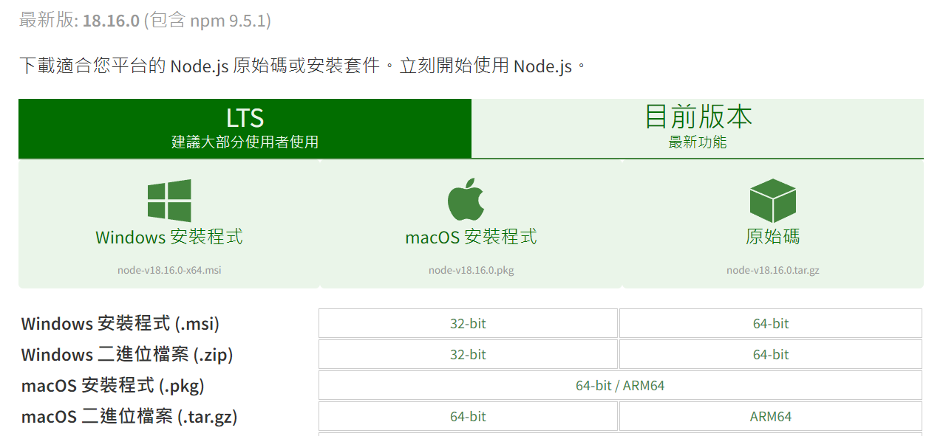
npx create-react-app my-react-app
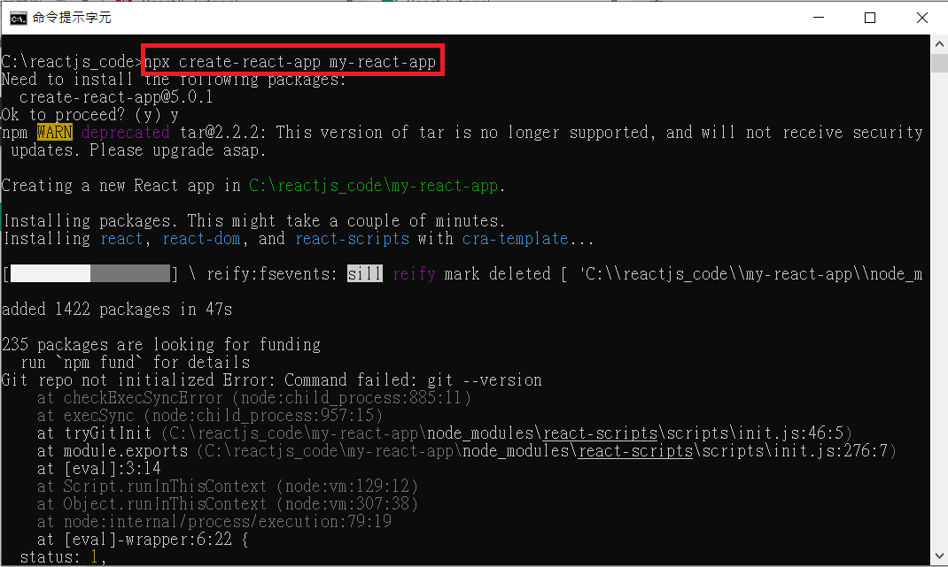
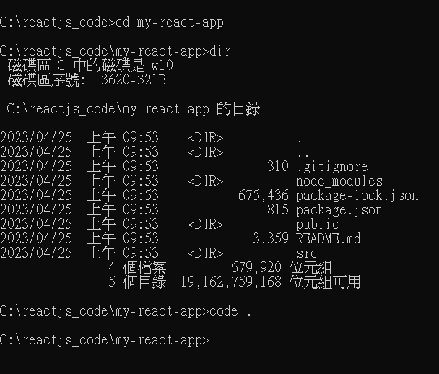
npm start
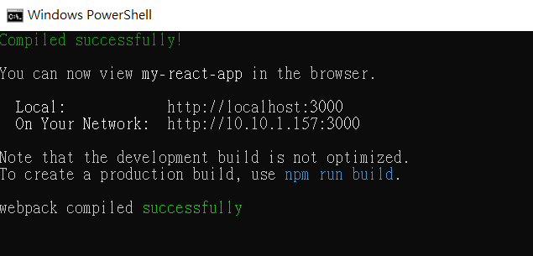
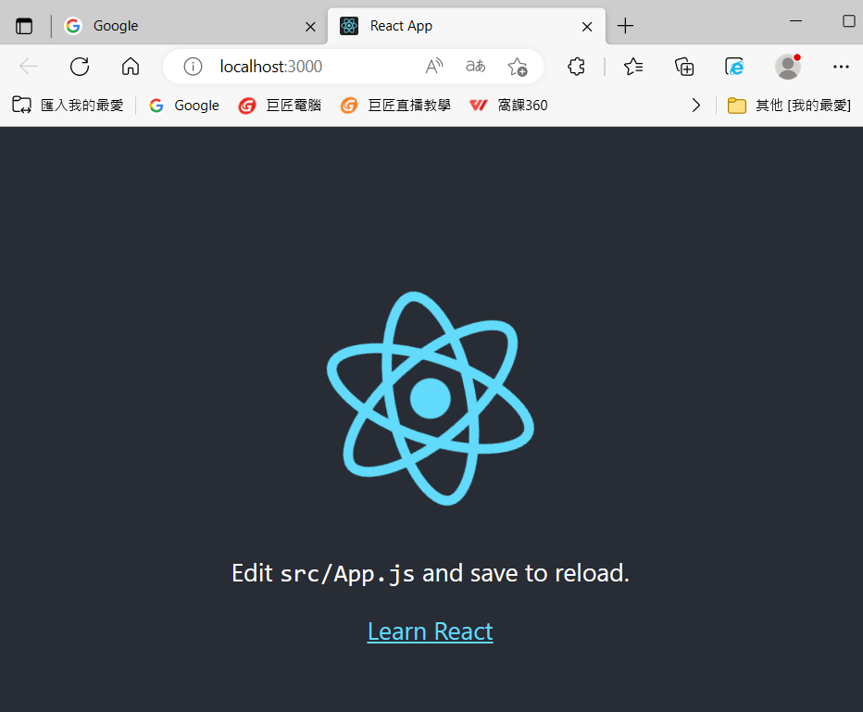
Hello.js

import React from "react";
import ReactDOM from "react-dom/client";

function Hello(props) {
return <h1>Hello World!</h1>;
}

const container = document.getElementById('root');
const root = ReactDOM.createRoot(container);
root.render(<Hello />);
export default Hello;
/*
The examples in this tutorial are created using the
create-react-app.

Install the create-react-app,
and you will be able to run the same examples on your computer.

In this example we create a component called 'Hello'.
The component is rendered in a container called 'root'.
*/
修改 index.js

import React from 'react';
import ReactDOM from 'react-dom/client';
import './index.css';
import App from './App';
import Hello from './Hello';
import reportWebVitals from './reportWebVitals';

const root = ReactDOM.createRoot(document.getElementById('root'));
root.render(
<React.StrictMode>
<Hello />
</React.StrictMode>
);

// If you want to start measuring performance in your app, pass a function
// to log results (for example: reportWebVitals(console.log))
// or send to an analytics endpoint. Learn more: https://bit.ly/CRA-vitals
reportWebVitals();
